SIMATS ENGINEERING
Department of Information Technology
CSA15 – CLOUD COMPUTING AND BIG DATA ANALYTICS
ASSIGNMENT 2 – CO2
Analyse, Evaluate and Validate a Virtualization Architecture for a Multi-Tenant University Private Cloud
CO2: Analyze virtualization architectures to identify performance and security issues in cloud computing environments.

Field | Details | Field | Details
Student Name | Y.Yogesh | Register Number | 192525004
Department / Section | Information Technology | Academic Year / Semester | 2026 /MS2 Sep-Dec
Faculty Name | Dr.Latha R | Nature of Assignment | Individual
Duration | 1 Week | Total Marks | 50
Submission Date | 04-11-2026 | Evaluation Date

MARK SHEET (Rubric-based evaluation)

Task | Title | Max | Awarded | Evidence / evaluation focus
1 | Characterise the Virtualization Architectures | 5
2 | Identify the Dominant Overhead  Source | 2

Task | Title | Max | Awarded | Evidence / evaluation focus
3 | Build a Quantitative Performance  Model | 6
4 | Analyse Performance Under Different  Conditions | 4
5 | Security Threat and Vulnerability Analysis | 3
6 | Formulate Isolation–Performance Trade-off | 3
7 | Evaluate Mitigation Strategies | 4
8 | Implement and Test | 4
9 | Record Experimental Performance | 3
10 | Compare Theory with Experiment | 4
11 | Recommend and Defend Final  Architecture | 4
 | Day-4 Design Challenge | 8

TOTAL
50

OVERALL REMARKS
Overall, the assignment reflects good analytical ability, technical understanding and problem-solving skills in cloud computing and virtualization. The proposed architecture balances performance, security, resource efficiency and future scalability. The work can be further strengthened through verified experimental results, consistent benchmark comparisons and practical validation of the recommended security controls.

Student Signature | Faculty Signature | Program Director

MANDATORY SUBMISSION EVIDENCE CHECK
✓ = Present in documented answer; P = Partly present; X = Missing / not satisfied

Task | Evidence expected | Status | Evaluator note
1 | Three virtualization architectures, layered diagrams and trust boundaries
2 | Dominant overhead source identified and explained for each approach
3 | CPU, memory, I/O, network and density models with assumptions
4 | Best, typical and worst operating-condition analysis

Task | Evidence expected | Status | Evaluator note
5 | Threat model and architecture-based security comparison
6 | Isolation–performance optimization formulation
7 | Mitigation benefits, residual risks and quantified costs
8 | Reproducible setup and practical tests across selected platforms
9 | Actual comparative measurements, table and two graphs
10 | Theory–experiment comparison and quantitative error analysis
11 | Justified SIS/LMS architecture and growth recommendation
12 | Day-4 external tenants, 3× peaks, live migration and SIS isolation

IMPLEMENTATION EVIDENCE CHAIN

Evidence item | Status | Observation
Architecture diagrams
Performance model

Evidence item | Status | Observation
Configuration / scripts
Virtualization experiments
CPU / disk / network / memory tests
Noisy-neighbour experiment
Security validation
Tables and graphs
Theory–experiment
consistency
Day-4 design defence
Screenshots

SUBMISSION CHECKLIST (Not Separately Marked)

Requirement | Status
All 12 tasks answered | - Yes ☐ Partly ☐ No
Three virtualization approaches compared | - Yes ☐ Partly ☐ No
Layered diagrams and trust boundaries included | - Yes ☐ Partly ☐ No
Quantitative virtualization models included | - Yes ☐ Partly ☐ No
Threat analysis and mitigations included | - Yes ☐ Partly ☐ No

TASK 1: Characterise the Virtualization Architectures

Selection of Virtualization Approaches
EduCloud must host the Student Information System (SIS), the Learning Management System (LMS), the examination portal and departmental research workloads on 16 shared hosts, and it must now also accommodate external Spark/Hadoop workloads. Three architecturally distinct approaches are characterised for this purpose. They are distinct because the isolation boundary sits in a different place in each of them and is enforced by a different component, not because they are different settings of one product.

Approach | Category | Component that enforces isolation | Kernel per instance
A. Type-1 hypervisor with hardware-assisted full virtualization (KVM/QEMU with virtio) | VM-based | CPU virtualization extensions (VT-x / AMD-V, EPT/NPT) and IOMMU,  programmed by the hypervisor | Full guest kernel
B. OS-level virtualization (Docker / containerd with runc) | Container-based | Shared host kernel (namespaces, cgroups v2, seccomp, SELinux/AppArmor) | None (shares host kernel)
C. Lightweight micro-VM / sandboxed container runtime (Kata Containers with Firecracker or Cloud Hypervisor) | Hybrid: container interface on a VM boundary | Hardware virtualization via a minimal VMM, plus guest-kernel namespaces inside the sandbox | Minimal guest kernel

The selection includes one VM-based approach (A) and one container-based approach (B), and Approach C sits between them: it keeps the container workflow used by modern big-data platforms while placing each workload behind a hardware virtualization boundary. Together they cover the full range of the isolation–efficiency spectrum that EduCloud has to choose from.
A Type-2 (hosted) hypervisor was not selected. It places a complete general-purpose host OS between the hypervisor and the hardware, which adds another scheduling layer and a larger attack surface, and it is intended for desktops rather than dedicated data-centre hosts. Paravirtualization is not treated as a separate approach, because in Approach A it is the mechanism (virtio drivers) used for I/O within the same hypervisor architecture.

Approach A: Type-1 Hypervisor with Hardware-Assisted Full Virtualization

Layered architecture
In this approach the Linux kernel with the KVM module acts as a bare-metal (Type-1) hypervisor. Each VM runs a complete, unmodified guest operating system, and each VM is represented on the host by one QEMU process that provides its device model.

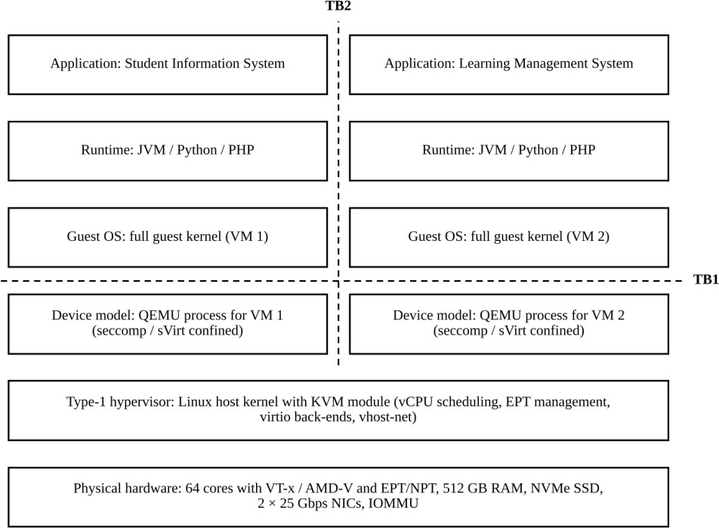

Figure 1: Layered architecture of the Type-1 hypervisor approach (KVM/QEMU) with trust boundaries TB1 and TB2

Trust boundaries and isolation enforcement
    - TB1 (guest to hypervisor): guest code runs in the CPU's non-root (guest) mode. Privileged instructions, certain I/O accesses and nested page faults cause a VM exit, which transfers control to KVM in root mode. This boundary is enforced by the CPU hardware, with KVM configuring it through the virtual machine control structure and the extended page tables.
    - TB2 (VM to VM): every VM has its own guest kernel and its own guest-physical address space mapped by EPT/NPT, so VMs share no kernel memory. The IOMMU restricts DMA from assigned devices to the memory of the owning VM.
    - Supporting confinement: the QEMU process runs unprivileged on the host and is restricted by seccomp, cgroups and SELinux (sVirt), so a flaw in device emulation does not directly give control of the host. The host kernel, KVM, QEMU and the management plane (for example libvirt or OpenStack) form the trusted computing base.

Virtualization of resources

Resource | Mechanism
CPU | Guest instructions execute directly on the physical core in guest mode. Each vCPU is a host thread scheduled by the Linux scheduler, which makes vCPU:pCPU overcommit possible. Privileged operations are trapped as VM exits and handled by KVM; timer and interrupt delivery use a virtual APIC.
Memory | Guest-physical memory is a region of the QEMU process's virtual address space. Hardware two-dimensional page walks (EPT/NPT) translate guest-virtual to guest-physical to host-physical addresses. Memory can be reclaimed through ballooning, page sharing (KSM) or host swapping.

Storage | The guest sees a virtio-blk or virtio-scsi disk. Requests are placed in shared virtqueues and served by QEMU (or a vhost back end) against a raw or qcow2 image on the shared storage backend or local NVMe. This is paravirtual I/O, so the guest driver cooperates and batches requests instead of driving an emulated physical controller.
Network | The guest sees a virtio-net interface. The vhost-net back end moves packets between the virtqueues and a TAP device attached to a Linux bridge or Open vSwitch, which forms the software-defined virtual network. The two 25 Gbps NICs are shared by all VMs on the host; SR-IOV is an optional alternative.

Relevance to EduCloud
This is the architecture on which EduCloud already runs, so it is the natural baseline against which the other two are compared. Separate guest kernels allow departments to run different operating systems and patch on their own schedule, and the hardware-enforced boundary suits the SIS and the examination portal, which hold student records. Mature features such as live migration, snapshots and VM templates make it practical to operate about 400 VMs. Its costs, namely a kernel and device model for every VM and the VM exits on the I/O path, are the reason the container-based alternatives need to be considered.

Approach B: OS-Level Virtualization (Containers)

Layered architecture
Containers do not virtualize hardware. All containers run as ordinary processes on one host kernel, and the kernel gives each of them a private view of the system and a limited share of its resources. There is no guest operating system; a container image carries only user-space libraries and the application runtime.

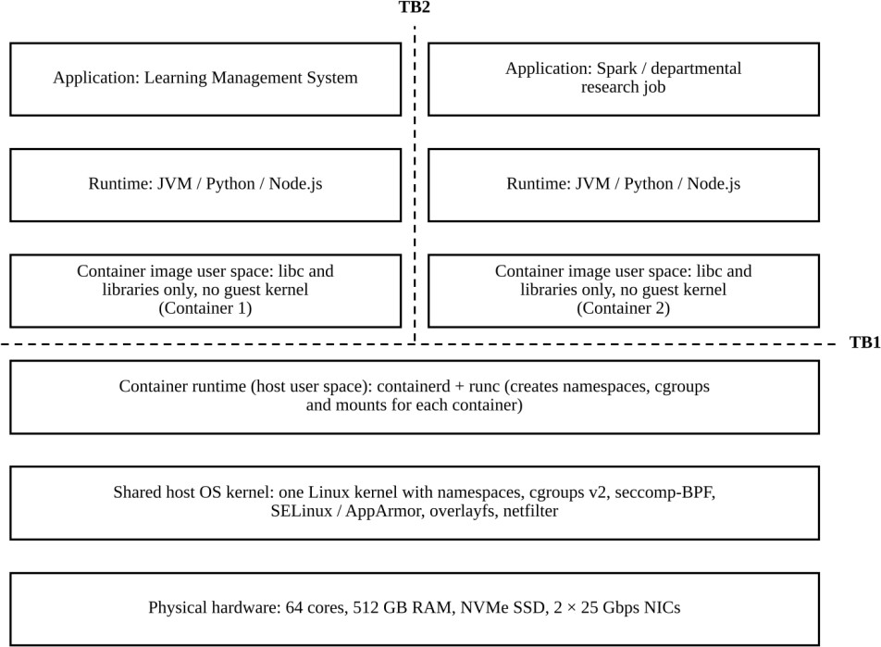

Figure 2: Layered architecture of the OS-level virtualization approach (containerd/runc) with trust boundaries TB1 and TB2

Trust boundaries and isolation enforcement
    - TB1 (container to host kernel): container processes reach the hardware only through the system-call interface of the single shared kernel. Namespaces (PID, mount, network, IPC, UTS, user), cgroups v2, dropped capabilities, seccomp-BPF filters and an LSM policy (SELinux or AppArmor) limit what each container can see and do.
    - TB2 (container to container): separation between co-located containers depends entirely on the correctness of the shared kernel and the container configuration. There is no hardware-enforced boundary between them, so a kernel vulnerability or a privileged container can affect every container on the host.
    - Trusted computing base: the host kernel together with containerd and runc, which run with host privileges, and the image registry from which images are pulled.

Virtualization of resources

Resource | Mechanism
CPU | There is no virtual CPU. Container processes are scheduled directly by the host scheduler, and cgroup controls (cpu.weight for proportional share, cpu.max for a quota, cpuset for pinning) limit their usage.
Memory | Processes use host physical memory through ordinary single-level page tables. The memory.max and memory.high controls limit usage per container; exceeding the limit triggers reclaim and finally an out-of-memory kill. There is no guest kernel memory footprint.

Storage | The root file system is assembled from read-only image layers plus a writable layer using overlayfs. Persistent data is provided through bind-mounted volumes on the shared storage backend, and io.max throttles block I/O. I/O goes directly through the host block layer.
Network | Each container has its own network namespace connected by a veth pair to a Linux bridge (with NAT) or to an overlay network such as VXLAN across hosts. Policy is enforced by netfilter or eBPF, and traffic passes through the host network stack.

Relevance to EduCloud
Containers start quickly, have a very small per-instance footprint and run close to native speed, which makes them attractive for scaling LMS and portal front ends during registration week and for running many Spark or Hadoop workers per host. Patching the single host kernel also addresses the audit finding of outdated guest kernels for all containers at once. The shared kernel and the free copying of images between teams, however, are weaknesses that must be examined in the later tasks.

Approach C: Lightweight Micro-VM / Sandboxed Container Runtime

Layered architecture
Kata Containers presents the standard container interface (OCI and Kubernetes) but starts each pod inside its own lightweight virtual machine. A minimal virtual machine monitor such as Firecracker or Cloud Hypervisor runs on KVM and boots a small guest kernel; an agent inside the guest then starts the containers of the pod.

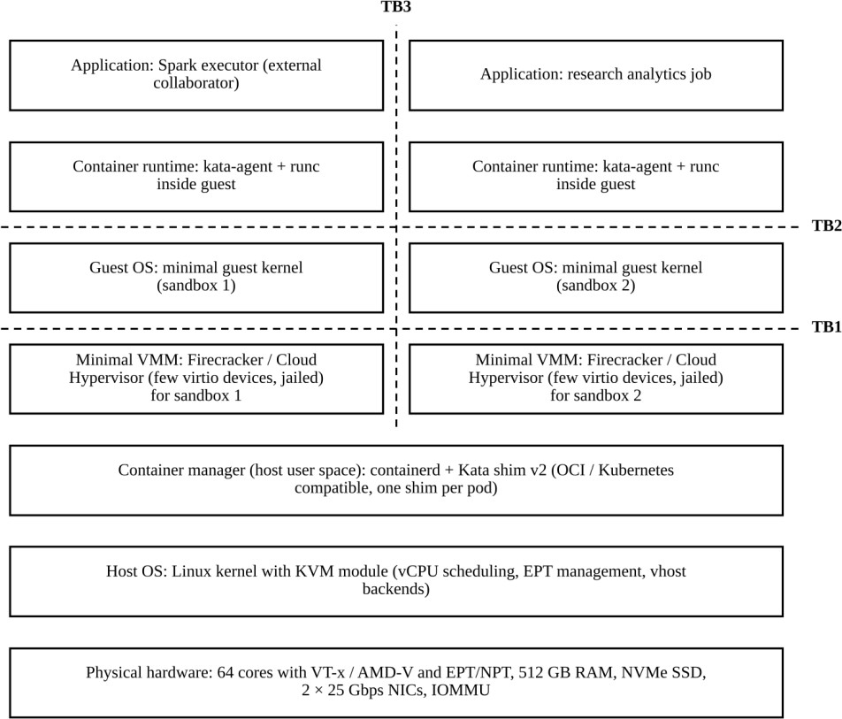

Figure 3: Layered architecture of the micro-VM / sandboxed runtime approach (Kata Containers) with trust boundaries TB1 to TB3

Trust boundaries and isolation enforcement
    - TB1 (guest sandbox to VMM and host): as in Approach A, hardware virtualization (VT-x or AMD-V with EPT/NPT) separates the guest from the host. The VMM exposes only a small set of virtio devices and omits legacy emulation such as BIOS, USB and VGA, and it is itself jailed with seccomp, cgroups and namespaces, which reduces the code reachable from a malicious guest.
    - TB2 (container to guest kernel): the containers inside a sandbox are still separated by namespaces and cgroups, but these are enforced by the guest kernel and not the host kernel. A container escape therefore reaches only the guest kernel of that sandbox.
    - TB3 (sandbox to sandbox): each sandbox has its own guest kernel, its own EPT-mapped memory and its own VMM process, so isolation between tenants is enforced in hardware, with the guest-kernel namespaces as a second layer of defence.

Virtualization of resources

Resource | Mechanism
CPU | vCPUs are KVM threads scheduled by the host Linux scheduler, as in Approach A, and the number of vCPUs of a sandbox can be adjusted with hot-plug. Guest code runs natively, and privileged operations cause VM exits. The minimal guest and device set means fewer emulated devices and timers.

Memory | Guest memory is mapped through EPT/NPT, as in Approach A. Sandbox memory can be resized with ballooning or virtio-mem, and the container root file system can be shared with the host (virtio-fs, optionally with DAX) to avoid duplicating data in the guest page cache.
Storage | Container image layers prepared on the host are exposed to the guest as a shared file system (virtio-fs) or as a virtio-blk device, depending on the VMM. Requests cross the guest kernel and the VMM before reaching the host storage backend.
Network | The guest has a virtio-net interface backed by a TAP device on the host. The container's veth interface is connected to this TAP device (for example with traffic-control redirection), so existing container network plug-ins continue to work. Packets cross both the guest network stack and the host virtual network.

Relevance to EduCloud
The planned hosting of external collaborators' Spark and Hadoop workloads on the same infrastructure as the SIS means running code that EduCloud does not control next to sensitive student data. Approach C allows these workloads to be deployed with the same container images and orchestration tools as Approach B while placing each of them behind a hardware-enforced boundary, and its minimal VMM and small guest give a smaller footprint and faster start-up than a conventional full VM.

Summary of the Characterisation

Aspect | A: Type-1 hypervisor (KVM/QEMU) | B: Containers (containerd/runc) | C: Micro-VM (Kata Containers)
Isolation boundary | Hardware virtualization between VMs (TB1, TB2) | Shared kernel interface (TB1, TB2) | Hardware virtualization plus guest-kernel namespaces (TB1 to TB3)
Isolation enforced by | CPU extensions, EPT/NPT, IOMMU | Host kernel: namespaces, cgroups, seccomp, LSM | CPU extensions, EPT/NPT, minimal VMM; guest kernel
Kernel per instance | Full guest kernel | None | Minimal guest kernel
CPU  virtualization | vCPU threads with VM exits | Native processes with cgroup limits | vCPU threads with VM exits
Memory virtualization | Two-dimensional page walk (EPT/NPT) | Native page tables with cgroup limits | Two-dimensional page walk (EPT/NPT)
I/O path | virtio via QEMU / vhost | Direct through host kernel | virtio via minimal VMM and guest kernel
Candidate role in EduCloud | Strongly isolated hosting of SIS, examination portal and legacy departmental VMs | Trusted, elastic, high-density services such as LMS front ends | Untrusted or external multi-tenant big-data workloads

These three characterisations provide the structure for the remaining tasks: the dominant overhead source of each approach follows from its resource-virtualization path described above, and the trust boundaries identified here form the basis of the threat model.

